**Practical-1**

**Aim: Write C program to print all negative elements in an array.**

**Program:**

#include<stdio.h>

main()

{

int n,i;

printf("=> Enter array size :- ");

scanf("%d",&n);

int a[n];

for(i=0;i<n;i++)

{

printf(" a[%d] :- ",i);

scanf("%d",&a[i]);

}

printf("\n\n=> All nagetive number :- ");

for(i=0;i<n;i++)

{

if(a[i]<0)

{

printf(" %d ",a[i]);

}

}

}

**Output:**

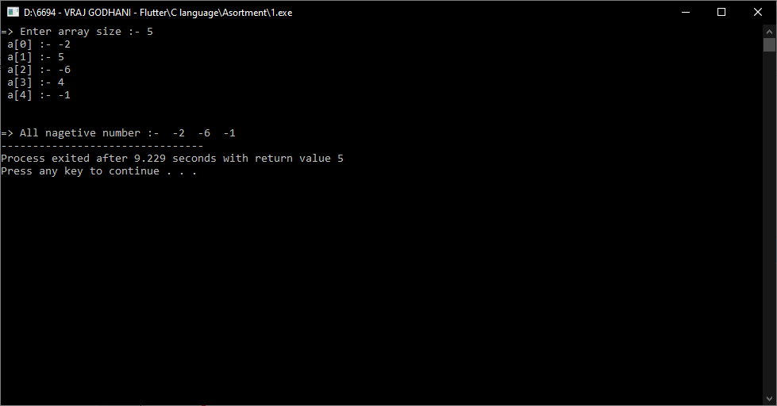

**Practical-2**

**Aim: Write C program to find second largest number in array.**

**Program:**

#include<stdio.h>

main()

{

int n,i,first,second;

printf("=> Enter array size :- ");

scanf("%d",&n);

int a[n];

for(i=0;i<n;i++)

{

printf(" a[%d] :- ",i);

scanf("%d",&a[i]);

}

first = second;

for(i=0;i<n;i++)

{

if(a[i]>first)

{

second=first;

first=a[i];

}

else if( a[i]>second && a[i]<first )

{

second=a[i];

}

}

printf("\n\n=>Second largest number is :- %d",second);

}

**Output:**

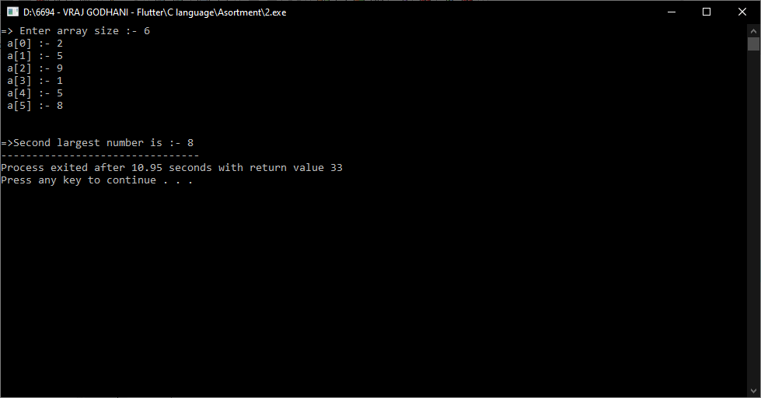

**Practical-3**

**Aim: Write C program to count frequency of each element in an array.**

**Program:**

#include <stdio.h>

main()

{

int n,i,j,count;

printf("Enter size of array: ");

scanf("%d", &n);

int a[n],b[n];

for(i=0;i<n;i++)

{

printf("a[%d]:-",i);

scanf("%d",&a[i]);

b[i] = -1;

}

for(i=0; i<n; i++)

{

count = 1;

for(j=i+1; j<n; j++)

{

if(a[i]==a[j])

{

count++;

b[j] = 0;

}

}

if(b[i] != 0)

{

b[i] = count;

}

}

printf("\nFrequency of all elements of array : \n");

for(i=0; i<n; i++)

{

if(b[i] != 0)

{

printf("%d element %d times\n", a[i],b[i]);

}

}

}

**Output:**

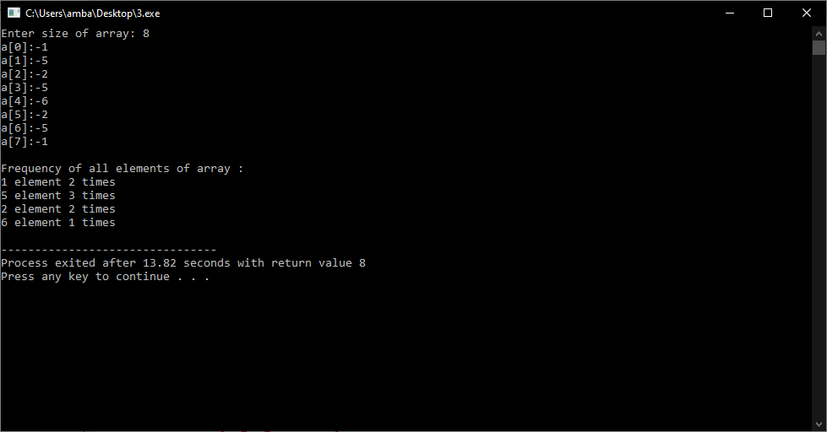

**Practical-4**

**Aim: Write C program to Insert, Delete & Update operations the element into array.**

**Program:**

#include<stdio.h>

main()

{

int choice;

printf("=> Prees 1 for insert the element into array.");

printf("\n=> Prees 2 for delete the element into array.");

printf("\n=> Prees 3 for update the element into array.");

int n,i,change,pos;

printf("\n\n=> Enter any choice :- ");

scanf("%d",&choice);

printf("\n=> Enter array size :- ");

scanf("%d",&n);

int a[n];

switch(choice)

{

case 1:

for(i=0; i<n; i++)

{

printf("a[%d]: ",i);

scanf("%d",&a[i]);

}

printf("\n=> Enter position :- ");

scanf("%d",&pos);

printf("\n=> Insert element :- ");

scanf("%d",&change);

a[pos]=change;

printf("=>\n=> After insert array : \n");

for(i=0; i<n; i++)

{

printf(" %d ",a[i]);

}

break;

case 2:

for(i=0; i<n; i++)

{

printf("a[%d]: ",i);

scanf("%d",&a[i]);

}

printf("\n=> Enter position :- ");

scanf("%d",&pos);

printf("=>\n=> After insert array : \n");

a[pos]==a[i];

for(i=0; i<n; i++)

{

if(i!=pos)

{

printf(" %d ",a[i]);

}

}

break;

default:

printf("=> Invalide choice.");

break;

}

}

**Output:**

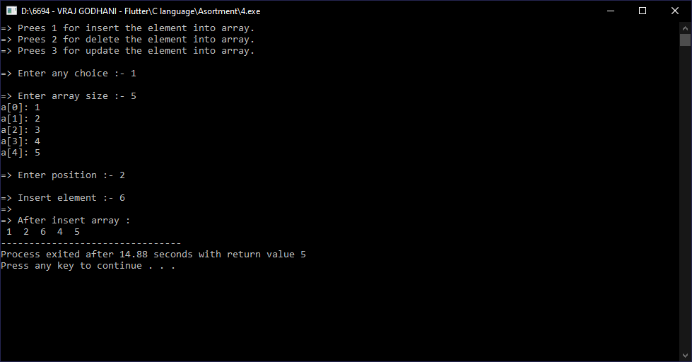

**Practical-5**

**Aim: Write C program to left rotate and right rotate an array.**

**Program:**

**Output:**

**Practical-6**

**Aim: Write C program to addition of two matrices.**

**Program:**

#include<stdio.h>

main()

{

int i,j,r,c;

printf("=> How many rows: ");

scanf("%d",&r);

printf("=> How many cols: ");

scanf("%d",&c);

printf("\n=> Enter array elements of a : \n");

int a[r][c],b[r][c],sum[r][c];

for(i=0;i<r;i++)

{

for(j=0;j<c;j++)

{

printf("a[%d][%d]: ",i,j);

scanf("%d",&a[i][j]);

}

}

printf("\n=> Enter array elemnets of b : \n");

for(i=0;i<r;i++)

{

for(j=0;j<c;j++)

{

printf("b[%d][%d]: ",i,j);

scanf("%d",&b[i][j]);

}

}

for(i=0;i<r;i++)

{

for(j=0;j<c;j++)

{

sum[i][j]=a[i][j]+b[i][j];

}

}

printf("\nSum of a and b matrix: \n");

for(i=0;i<r;i++)

{

for(j=0;j<c;j++)

{

printf("%d ",sum[i][j]);

}

printf("\n");

}

}

**Output:**

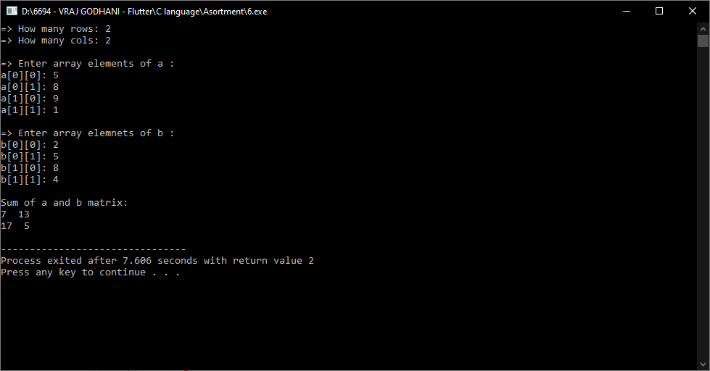

**Practical-7**

**Aim: Write C program matrix convert into transpose matrix.**

**Program:**

#include<stdio.h>

main()

{

int n,i,j;

printf("=> How many rows and cols : ");

scanf("%d",&n);

int a[n][n],t[n][n],sum=0;

printf("\n\n=> Enter array elements : \n");

for(i=0; i<n; i++)

{

for(j=0; j<n; j++)

{

printf("a[%d][%d]: ",i,j);

scanf("%d",&a[i][j]);

}

}

printf("\n =>Array : \n");

for(i=0; i<n ;i++)

{

for(j=0; j<n ;j++)

{

printf("%d ",a[i][j]);

}

printf("\n");

}

for(i=0; i<n; i++)

{

for(j=0; j<n; j++)

{

t[j][i]=a[i][j];

}

}

printf("\n=> Transpose matrix : \n");

for(i=0; i<n; i++)

{

for(j=0; j<n; j++)

{

printf("%d ",t[i][j]);

}

printf("\n");

}

}

**Output:**

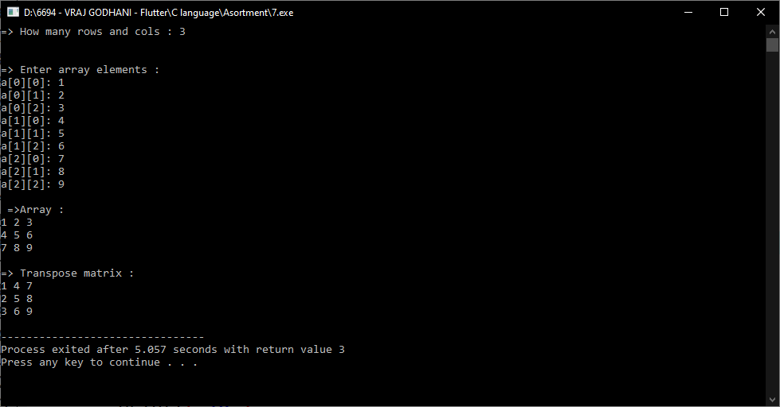

**Practical-8**

**Aim: Write C program to find sum of diagonal elements of a matrix.**

**Program:**

#include<stdio.h>

main()

{

int n,i,j;

printf("How many rows and cols : ");

scanf("%d",&n);

int a[n][n],sum=0;

printf("\n\n=> Enter array elements: \n");

for(i=0; i<n; i++)

{

for(j=0; j<n ;j++)

{

printf(" a[%d][%d]: ",i,j);

scanf("%d",&a[i][j]);

}

}

printf("\n\n=> Array elements : \n");

for(i=0; i<n; i++)

{

for(j=0; j<n; j++)

{

printf(" %d ",a[i][j]);

}

printf("\n");

}

for(i=0; i<n; i++)

{

for(j=0; j<n; j++)

{

if( i == j )

{

sum = sum+a[i][j];

}

}

}

printf("\n\n=> Sum of Diagonal : %d",sum);

}

**Output:**

